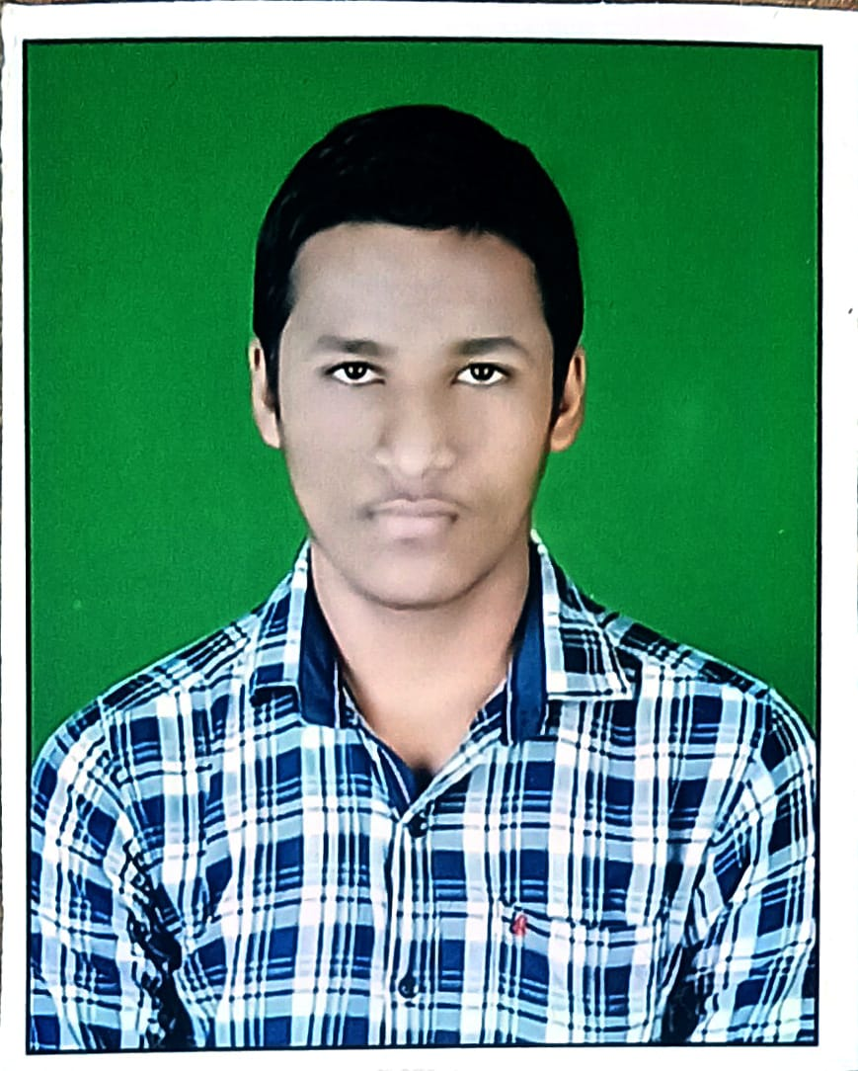
RESUME

ADITYA KUMAR KAR
S/o- Ananta Charan Kar
At-Bhuban,Po-Bhuban ,Ps-Bhuban
Dist-Dhenkanal, Pin-759017, Odisha
Mob-8260344844
Email ID –adityakar428@gmail.com

OBJECTIVE :
Intend to build my career at an esteemed organization which would tell my knowledge, help to achieve my goals and to move ahead in this competitive world while being resourceful, innovative and flexible.

EDUCATIONAL QUALIFICATION :
- Passed +2 Science from B.R.M. College Bhuban in the year 2023
- Passed H.S.C from Bhuban High School, Bhuban in the year 2021
- P.G.D.CA From Sai Trishna Computer Care, Bhuban
- Persuing B.tech in Gandhi Institute Of Excellent Technocrats in Bhubaneswar

COMPUTER SKILLS :
- Well versed with MS Word, Excel, Power Point, Outlook and Windows 2007 .
- Completed core java ,HTML,CSS ,JAVA SCRIPT, C, REACT ,DSA ,MYSQL,PYTHON
PERSONAL TRAITS :

- Self motivated with a positive attitude.
- The ability to work in a team.
- Adaptable to the changes in my surroundings.
- I take initiative to improving the things and convince others to join me.
- Interested in exploiting my theoretical knowledge as practical.

EXPERIENCE :
- Lab Assistance in Sai Trishna Computer Care.
- Making salesforce using UI in HTML,CSS,JAVA SCRIPT

PERSONAL DETAILS :
Name : Aditya Kumar Kar
Father’s Name : Ananta Charan Kar
Date of Birth : 19.06.2006
Marital Status : Unmarried
Languages Known : Oriya, Hindi & English,
Nationality : Indian
Religion : Hindu
Gender : Male

DECLARATION :
I consider myself fit and efficient for all type of situations and conditions. I am also confident of my ability to work in a team as I have proved it in my school, college and work field.

I hereby declare that the information furnished above is true to the best of my knowledge.

Place: Bhuban

Aditya Kumar Kar

